COOLANT RX•3-N-1
Dynamic Flush For Coolant Systems

Reference Manual



SAFETY INSTRUCTIONS

- This equipment may be operated with the engine running and at engine operating temperature.

- Engine coolant is hot and can cause serious burns.

- Gloves, safety glasses or a safety mask (preferred) must be worn when operating or being near this equipment.

- Be aware that liquid, such as coolant, boils at a low temperature when subjected to containment in a vacuum environment.

- A long-sleeved shirt or other arm protection is advised.

- Only qualified personnel are authorized to operate this equipment.

- Read all the instructions before operating this equipment.

- If the coolant starts to boil in the tubes, press the vacuum release button located o the top cap of the tube.

- Do not operate the engine without coolant for more than 3 minutes.

INTRODUCTION

THE 3 –n-1 COOLANT SYSTEM SERVICE MACHINE IS DESIGNED TO PERFORM SEVERAL FUNCTIONS RELATED TO COOLANT SYSTEM SERVICE. THEY ARE:

- REMOVE AND STORE OLD COOLANT
- STORE AND INSTALL NEW COOLANT.
- MIX COOLANT WITH THE CORRECT RATIO OF WATER.
- DETERMINE THE EXACT AMOUNT OF COOLANT THAT NEEDS TO BE INSTALLED IN THE VEHICLE’S COOLANT SYSTEM.
- “TOP OFF” THE COOLANT SYSTEM.
- DETERMINE IF THE COOLANT SYSTEM IS VACUUM TIGHT TO INSURE THERE ARE NO LEAKS.
- COMPARE OLD COOLANT TO NEW COOLANT.
- CHANGE FROM ONE TYPE OF COOLANT TO ANOTHER.
- FLUSH OUT THE COOLANT SYSTEM WITH WATER.

THE Quick-n-Easy METHOD OF REMOVING COOLANT FROM THE COOLANT SYSTEM IS OBTAINED BY UTILIZING VACUUM. BY USING VACUUM, GENERATED BY THE VACUUM GENERATOR, TO PULL A VACUUM IN THE MACHINE’S “OLD” COOLANT TUBE AND AT THE SAME TIME “PULLING” A VACUUM IN THE ENGINE’S COOLING SYSTEM, MOST OF THE COOLANT CAN BE REMOVED AND, IN MOST CASES, WITHOUT DISCONNECTIONG ANY RADIATOR HOSES. WHERE THE CIRCUMSTANCES DIRECT THAT A 100% EXCHANGE IS DEEMED NECESSARY THE “PUSH/PULL” TECHNIQUE DESCRIBED IN THIS MANUAL CAN BE EXERCISED.

A SERVICE HOSE, WITH A TAPERED RUBBER CONE ATTACHED, IS INSERTED IN PLACE OF THE RADIATOR CAP (FOR THE PUSH/PULL TECHNIQUE SEE THAT SECTION OF THIS MANUAL). THE MACHINES TUBE CONTROL VALVE IS THEN POINTED TO THE MARK LABELLED “OLD COOLANT”. THE MASTER CONTROL KNOB IS POINTED TO “VACUUM”. AS THE LIQUID IN THE ENGINE’S COOLANT SYSTEM BEGINS TO HEAT UP, THE VACUUM, GENERATED BY THE VACUUM GENERATOR, WILL LOWER THE BOILING POINT OF THE LIQUID, THEREBY ALLOWING IT TO BE DRAWN INTO THE TUBE. BY VISUALLY OBSERVING THE FLOW OF LIQUID IN THE TRNASPARENT SERVICE HOSE, IT CAN EASILY BE DETERMINED WHEN ALL OF THE AVAILABLE COOLANT HAS BEEN DRAWN FROM THE COOLANT SYSTEM.

THE “VACUUM” FUNCTION ON THE MASTER CONTROL KNOB IS ALSO USED TO DRAW COOLANT/WATER INTO THE TUBE AND TO DRAW COOLANT OUT OF THE COOLANT OVERFLOW/RECOVERY RESERVOIR.

THE “AIR PRESSURE” FUNCTION IS USED TO APPLY PRESSURE TO THE OLD COOLANT IN ORDER TO REMOVE IT FROM THE “OLD COOLANT” TUBE.

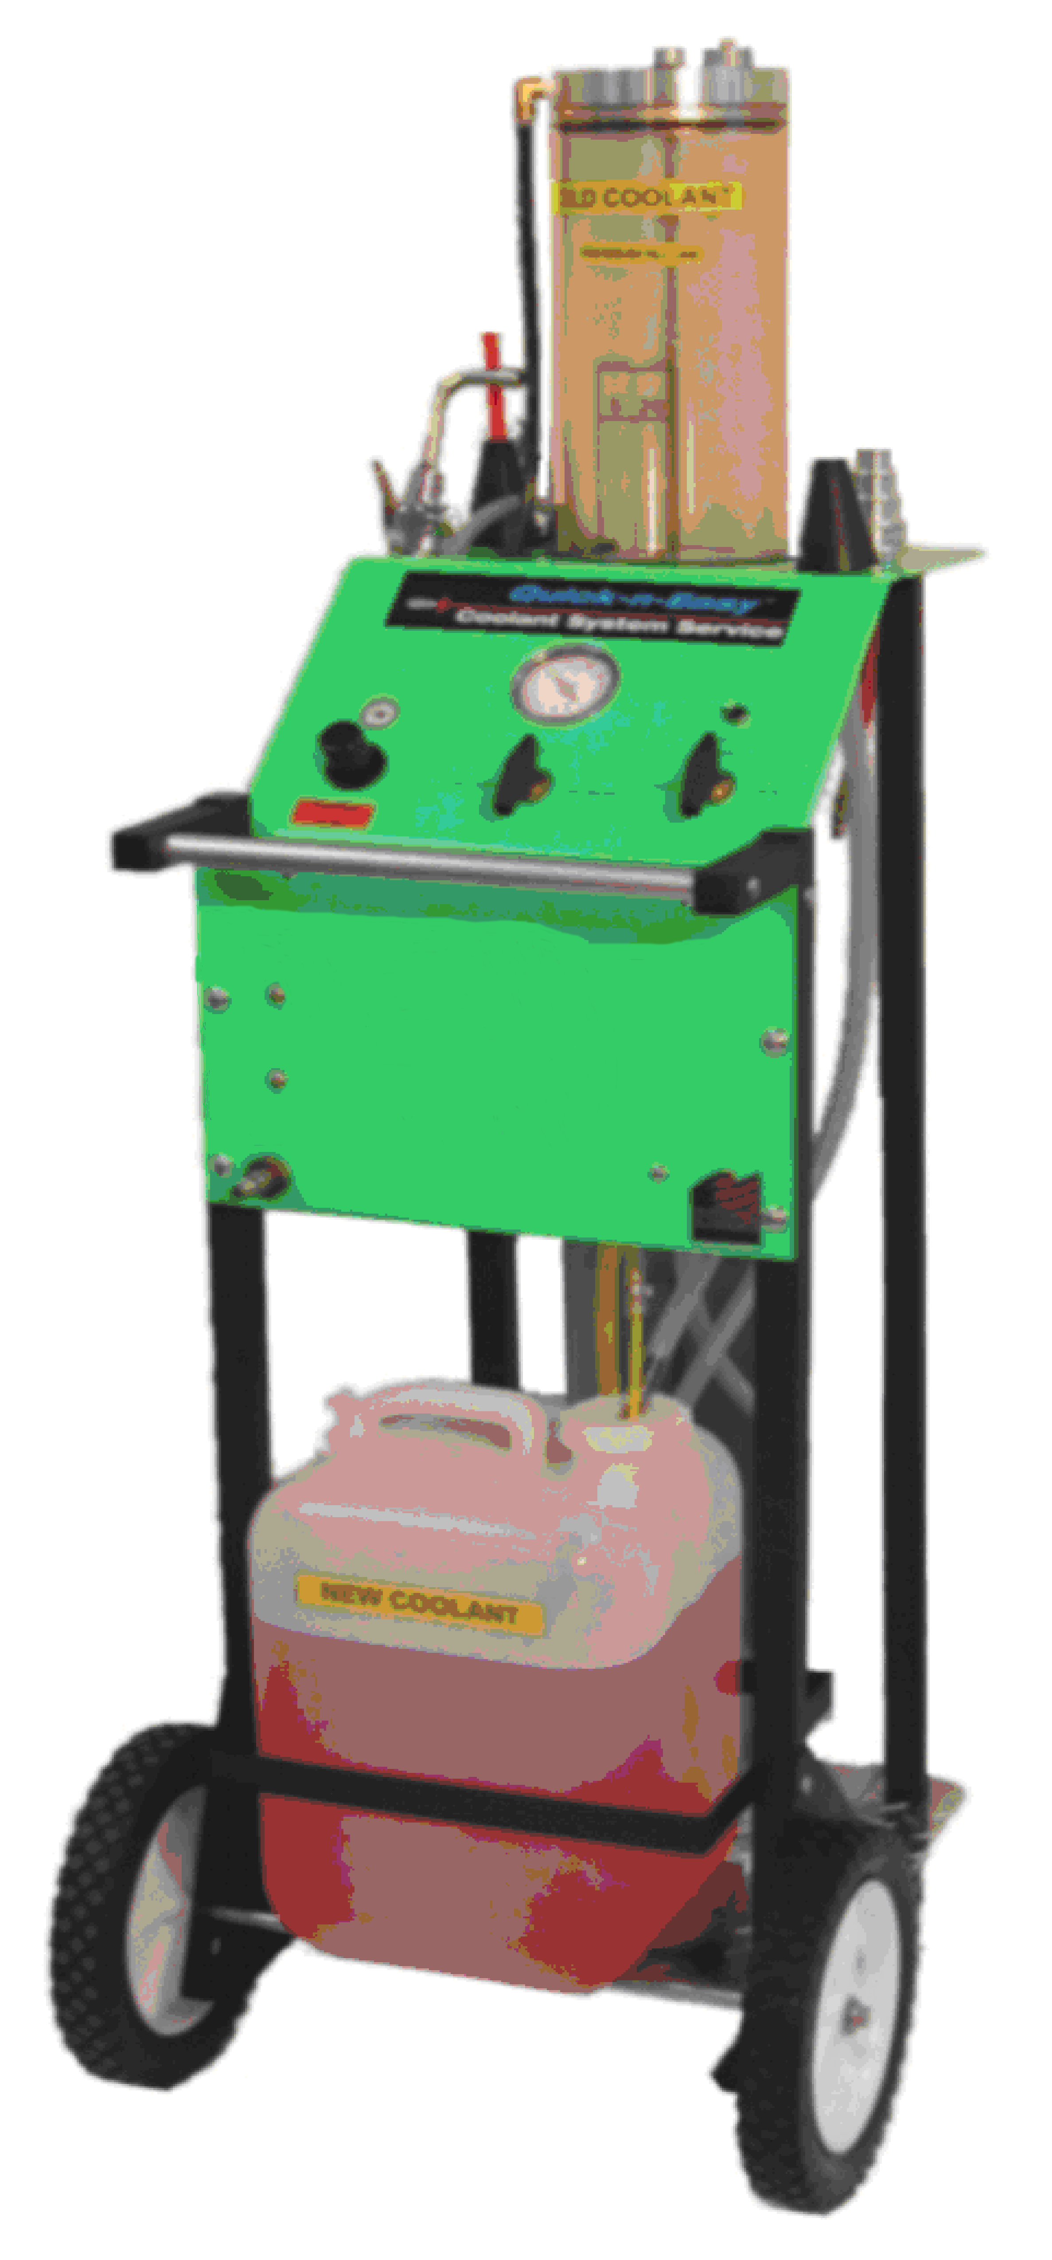
1
2
3
4
5
6
11
12
7
8
9
10
FIGURE A

FIGURE B

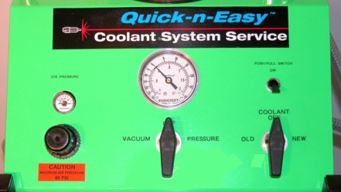
4
5
6
7
8
3

FIGURE C
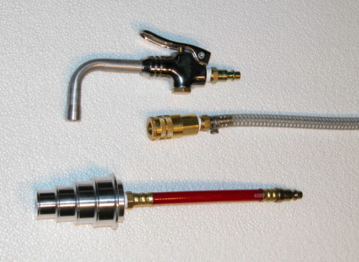
14
12
13

HOW TO USE THE 3-n-1 COOLANT SYSTEM

THE 3 in 1 COOLANT SYSTEM CAN BE USED AS A STRAIGHT “VACUUM” SYSTEM OR
AS A PUSH/PULL SYSTEM.

THE “VACUUM” METHOD IS THE MOST COMMON USED AND IT WILL REMOVE AN AVERAGE OF 85% OF THE COOLANT IN LESS THAN 4 MINUTES. THIS METHOD CAN BE PERFORMED WITHOUT DISCONNECTING ANY RADIATOR HOSES OR OPENING ANY PETCOCKS. THE ENGINE MUST BE AT OPERATING TEMPERATURE (THERMOSTAT OPEN) AND PREFERABLY WITH THE ENGINE RUNNING.

THE “PUSH/PULL” METHOD TAKES A LITTLE LONGER (ABOUT 7 MIMUTES) AND IT WILL
EXCHANGE 100% OF THE COOLANT. YOU HAVE TO DISCONNECT ONE END OF THE UPPER RADIATOR HOSE. THE ENGINE DOES NOT NEED TO BE RUNNING AND DOES NOT NEED TO BE A OPERATING TEMPERATURE. HOWEVER, A WARM ENGINE WILL PRODUCE FASTER RESULTS.

THE “VACUUM” METHOD.
- PLACE A SUFFICIENT AMOUNT OF COOLANT IN THE 5-GALLON RESERVOIR.
- ATTACH AN AIR LINE AS INDICATED IN FIGURE A. CHECK THE AIR PRESSURE AND IF NEEDED ADJUST TO 80-90 PSI.
- INSERT THE ONE END OF THE ORANGE TUBE INTO THE BRASS SLEEVE ON THE END OF THE SERVICE LINE (FIGURE D). TURN THE TUBE CONTROL KNOB TO “OLD COOLANT” AND THE MASTER CONTROL KNOB TO “VACUUM” (FIGURE E). REMOVE THE RADIATOR CAP AND SUCK OUT 2 OR 3 INCHES OF COOLANT. THEN SUCK ALL OF THE COOLANT OUT OF THE OVERFLOW RESERVOIR. TURN THE MASTER CONTROL KNOB TO “OFF”.
- START THE ENGINE AND TURN ON THE HEATER. LET THE ENGINE WARM UP UNTIL THE THERMOSTAT OPENS. LEAVE THE RADIATOR CAP OFF.
- INSERT THE BLACK RUBBER CONE ONTO THE SERVICE LINE (FIGURE F) AND INSERT THE CONE INTO THE RADIATOR OPENING AND PUSH DOWN.
- TURN THE TUBE CONTROL KNOB TO “OLD COOLANT” AND THE MAIN CONTROL KNOB TO “VACUUM” (FIGURE E).
- COOLANT WILL START TO RISE IN THE OLD COOLANT TUBE. WHEN IT STOPS
RISING GRAB THE RUBBER CONE (ENGINE RUNNING AND VACUUM STILL
ON) AND REMOVE IT FROM THE RADIATOR OPENING. NOW REINSTALL IT IN
THE RADIATOR OPENING. THIS IS CALLED “BURPING” THE SYSTEM AND YOU
MAY HAVE TO DO IT SEVERAL TIMES. WHEN YOU ARE SATISFIED YOU HAVE
REMOVED AS MUCH COOLANT AS POSSIBLE (DO NOT RUN THE ENGINE
WITHOUT COOLANT FOR MORE THAN 2 MINUTES) YOU ARE READY TO
INSTALL THE NEW COOLANT.

USING THE 3-n-1 COOLANT SYSTEM-CONTINUED

8. TURN THE TUBE CONTROL VALVE TO “NEW COOLANT” (FIGURE G). DO NOT
MOVE THE MAIN CONTROL VALVE FROM “VACUUM”. JUST TURN THE TUBE
CONTROL VALVE TO “NEW COOLANT” AND COOLANT WILL START TO FLOW
BACK INTO THE RADIATOR. WHEN THE RADIATOR IS FULL (HINT; THE UPPER
RADIATOR HOSE WILL “POP” BACK INTO ITS ORIGINAL SHAPE) TURN ALL
THE VALVE TO “OFF”.

- TOP OFF THE RADIATOR, IF NEEDED, AND FILL THE OVERFLOW RESERVOIR BY
ATTACHING THE HOSE BIB TO THE PUSH/PULL HOSE (FIGURE C) AND FLIPPING THE PUSH/PULL SWITCH UP (FIGURE B). WHEN THE RADIATOR AND OVERFLOW RESERVOIR ARE FULL TURN ALL VALVES AND SWITCHES TO “OFF”.

- LET THE ENGINE RUN UNTIL YOU ARE SATISFIED THAT THERE IS NO AIR
TRAPPED IN THE COOLANT SYSTEM. INSTALL THE RADIATOR CAP.

- TO EMPTY THE OLD COOLANT FROM THE OLD COOLANT TUBE PLACE THE
END OF THE SERVICE LINE IN A RECEPTABLE FOR OLD COOLANT AND TURN
THE TUBE CONTROL VALVE TO “OLD COOLANT” AND THE MAIN CONTROL
VALVE TO “PRESSURE” (FIGURE H). WHEN THE TUBE IS EMPTY TURN ALL
VALVES TO OFF.
FIGURE D

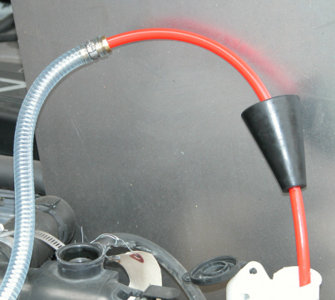
ORANGE HOSE ATTACHED TO SERVICE LINE SUCKING COOLANT FROM RESERVOIR

PAGE 8

FIGURE E

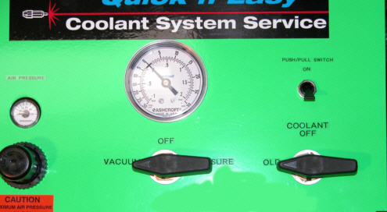

EMPTYING OLD COOLANT. TUBE CONTROL KNOB ON “OLD COOLANT” AND MASTER CONTROL KNOB ON “VACUUM”

FIGURE F
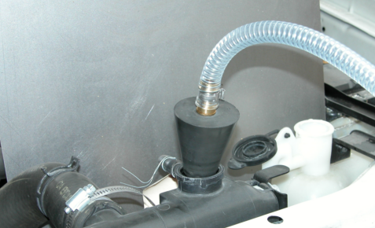

BLACK RUBBER CONE SHOWN ON SERVICE LINE AND PLACED IN RADIATOR OPENING. READY TO REMOVE OLD COOLANT.

FIGURE G

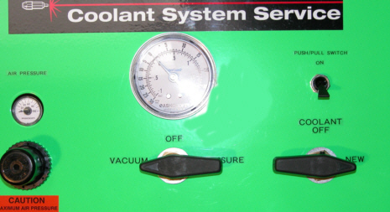

INSTALLING NEW COOLANT. MAIN CONTROL KNOB IS ON “VACUUM’ AND TUBE CONTROL KNOB IS ON “NEW”.

FIGURE H

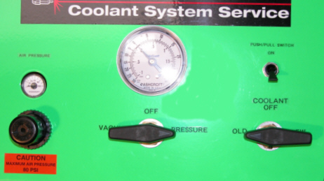

REMOVING OLD COOLANT FROM THE TUBE. MAIN CONTROL KNOB IS ON “PRESSURE” AND TUBE CONTROL KNOB IS ON “OLD COOLANT”.

THE PUSH/PULL METHOD READ THE INSTRUCTIONS IN THE VACUUM
METHOD SECTION. THE PUSH/PULL METHOD INCLUDES MOST OF THE
TECHNIQUES DESCRIBED IN THE VACUUM METHOD.

- FOLLOW THE STEPS 1, 2 and 3 IN THE VACUUM METHOD SECTION. MAKE SURE THE COOLANT IN THE RADIATOR HAS BEEN SUCKED DOWN TO THE CORE (BELOW THE UPPER RADIATOR HOSE CONNECTION). IT IS BEST IF THE ENGINE IS WARM. ALSO, THE ENGINE IS NOT RUNNING BUT THE HEATER IS ON. THE RADIATOR CAP MUST BE ON AND TIGHT.

- DETERMINE WETHER THE COOLANT SYSTEM IS A FORWARD FLOW (COOLANT FLOWS FROM THE TOP OF THE RADIATOR TO THE BOTTOM) OR A REVERSE FLOW SYSTEM (COOLANT FLOWS FROM THE BOTTOM OF THE RADIATOR TO THE TOP). IF YOU ARE NOT SURE, OBSERVE THE WATERPUMP DRIVE BELT. IF IT IS A “SERPENTINE” BELT THE SYSTEM IS A REVERSE FLOW TYPE. IN THIS CASE DISCONNECT THE TOP RADIATOR HOSE FROM THE RADIATOR AND INSERT THE RUBBER CONE INTO THE RADIATOR OPENING THAT YOU DISCONNECTED THE TOP HOSE FROM. INSTALL THE STEPPED ALUMINUM ADAPTER INTO THE END OF THE TOP RADIATOR HOSE THAT YOU DISCONNECTED. BE SURE TO USE A WORM DRIVE CLAMP TO HOLD THE ADAPTER IN PLACE. IF IT IS A FORWARD FLOW SYSTEM DISCONNECT THE UPPER RADIATOR HOSE AT THE THERMOSTAT HOUSING. INSTALL THE RUBBER CONE IN THE THERMOSTAT HOUSING AND THE STEPPED ADAPTER IN THE HOSE YOU DISCONNECTED.

- CONNECT THE STEPPED ADAPTER (FIGURE “C”, ITEM 13, PAGE 6) TO THE OPEN
RADIATOR HOSE. USE A WORM DRIVE CLAMP-DO NOT USE A SPRING CLAMP
AS IT WILL NOT HOLD THE PRESSURE (SEE FIGURE “J”).

- INSERT THE SHORT ORANGE TUBE IN THE SMALL END OF THE RUBBER CONE
(FIGURE “I”) WITH THE CURVE POINTING DOWN. TIGHTLY INSERT THE CONE
IN THE PORT YOU DISCONNECTED THE HOSE FROM (FIGURE “K”).

- TURN THE MAIN CONTROL KNOB TO “VACUUM” AND THE TUBE KNOB TO “OLD” (FIGURE “E”). FLIP THE “PUSH/PULL SWITCH” TO “ON”.

- WHEN YOU ARE SATISFIED THAT YOU HAVE EXCHANGED 100% OF THE OLD COOLANT WITH NEW COOLANT TURN OFF THE “PUSH/PULL SWITCH”.

- LEAVE THE VACUUM ON FOR A FEW SECONDS IN ORDER TO SUCK OUT EXCESS COOLANT FROM THE RADIATOR UPPER TANK. THIS WAY YOU WILL NOT HAVE A SPILL WHEN YOU DISCONNECT THE ADAPTERS.

- DISCONNECT ALL THE ADAPTERS AND RECONNECT THE UPPER RADIATOR HOSE.

- CONNECT THE HOSE BIB TO THE PUSH/PULL HOSE AND TOP OFF THE RADIATOR AND OVERFLOW RESERVOIR BY TURNING ON THE PUSH/PULL SWITCH.

- RUN THE ENGINE WITH THE RADIATOR CAP OFF TO PURGE ANY AIR OUT OF THE SYSTEM.

FIGURE I

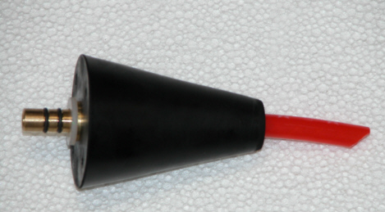

INSERT THE SHORT ORANGE TUBE IN THE CONE. HAVE THE OPENING POINTING DOWN SO YOU CAN SUCK OUT EXCESS COOLANT.

FIGURE J
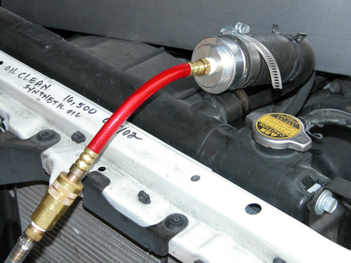

CONNECT THE STEPPED CONE TO THE PUSH/PULL HOSE. INSERT THE CONE IN THE PROPER END OF THE RADIATOR HOSE. USE A WORM DRIVE CLAMP TO HOLD IT.
REVERSE FLOW SYSTEM SHOWN.

FIGURE K

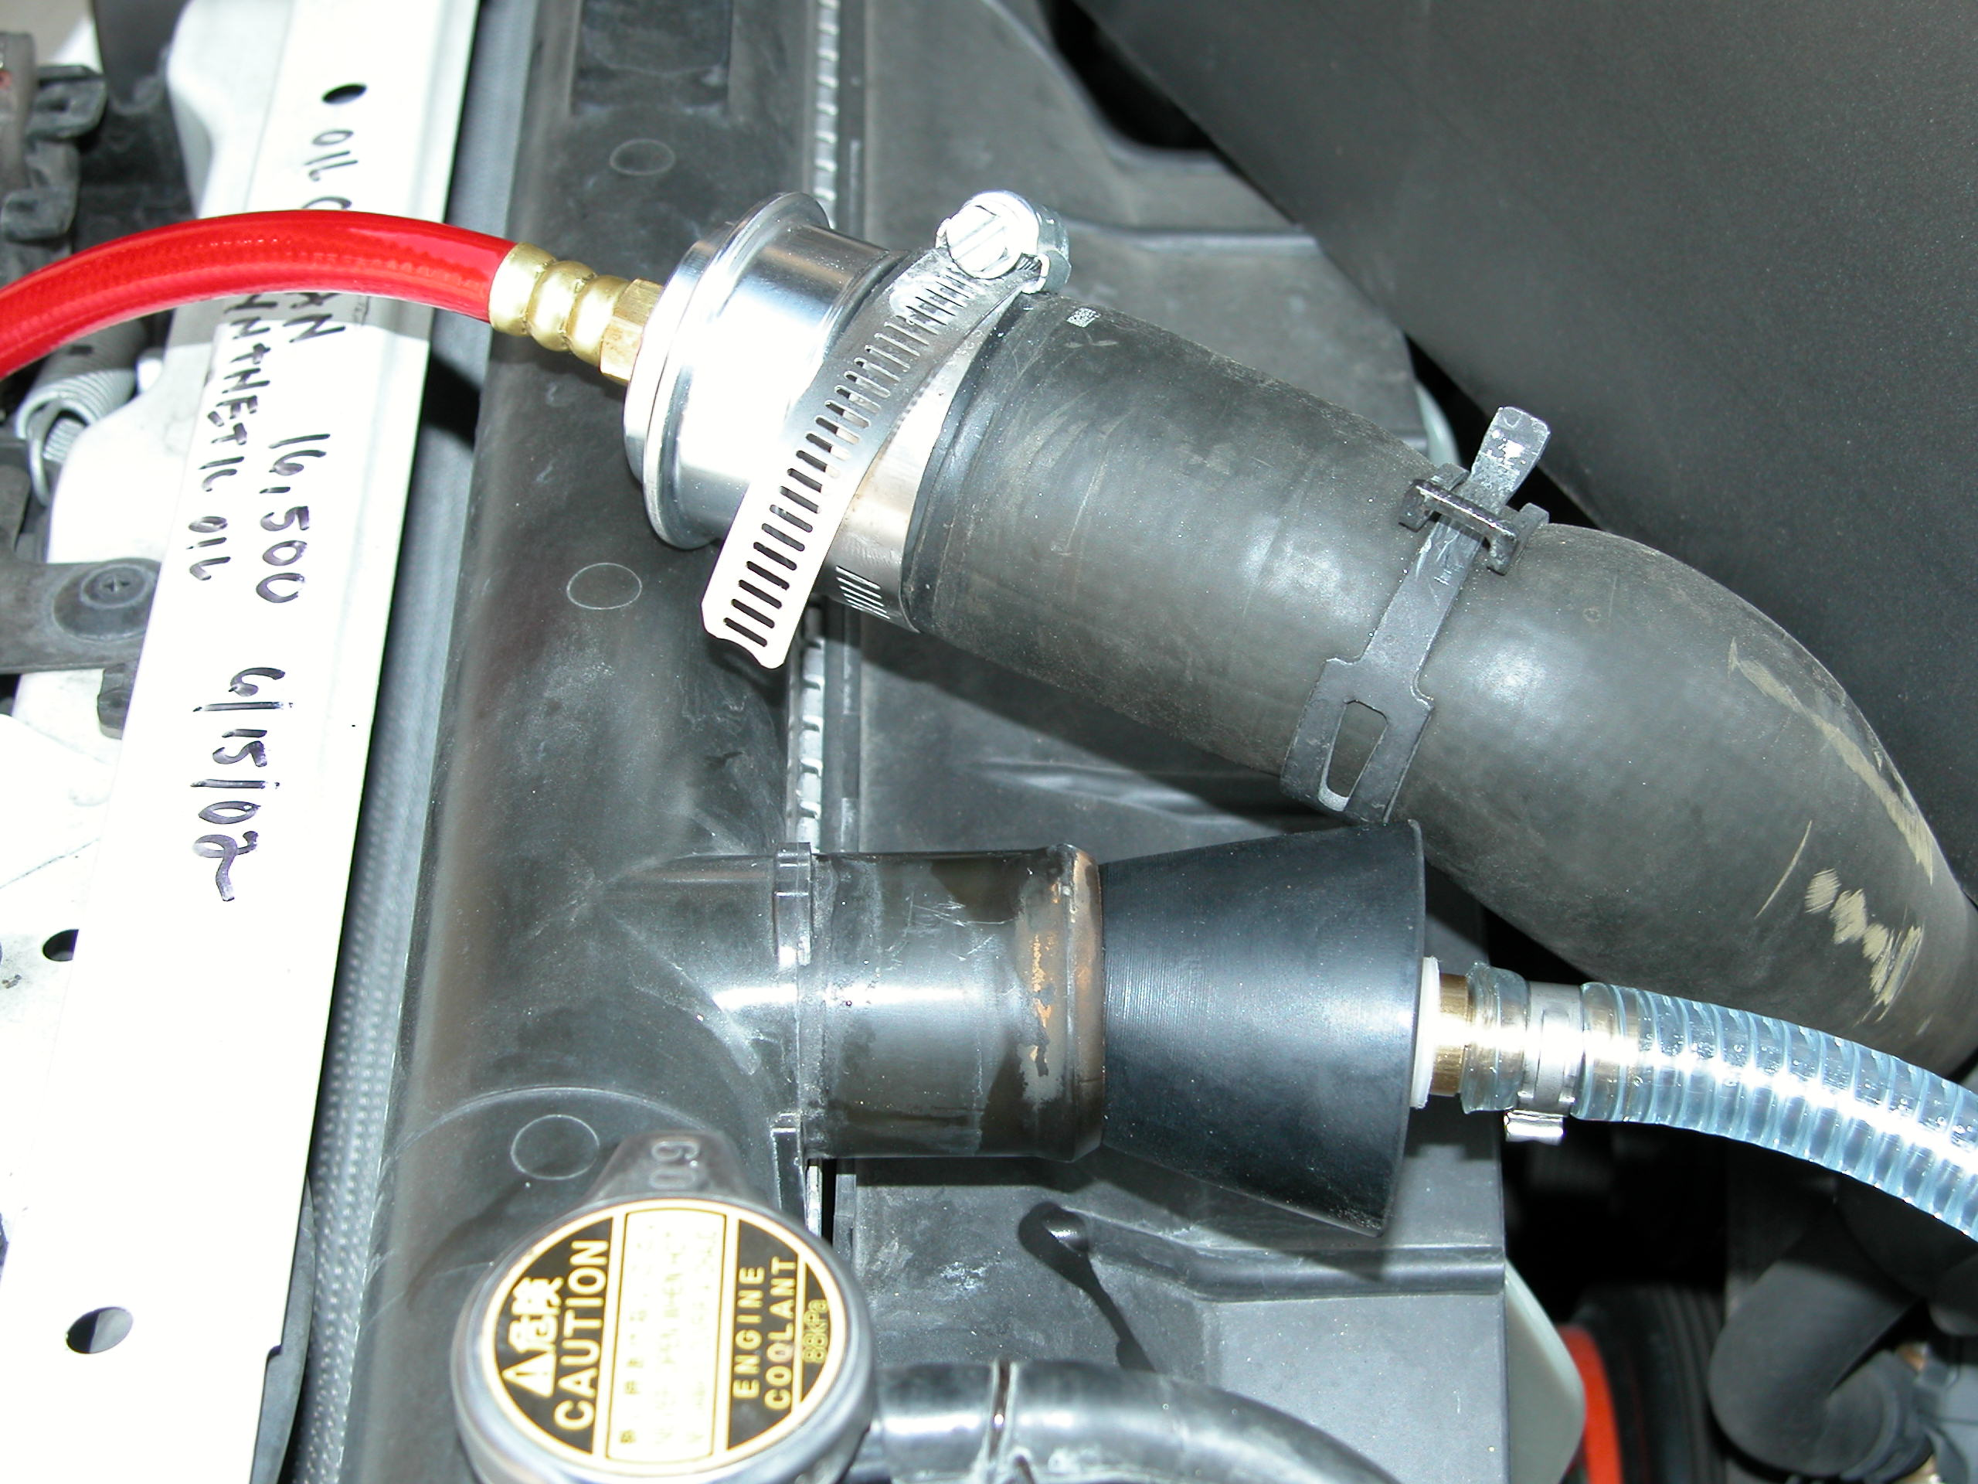

REVERSE FLOW SYSTEM SHOWN
NOTE THAT REVERSE FLOW SYSTEMS HAVE A SERPENTINE BELT

TIPS ON USING YOUR 3-n-1 COOLANT SYSTEM

THE MOST COMMON CONCERN WHEN USING THE 3-n-1 MACHINE IS THAT IT DOES NOT REMOVE ALL THE COOLANT IN THE “VACUUM” MODE. FIRST, IT IS VIRTUALLY IMPOSSIBLE TO REMOVE MORE THAN AN AVERAGE OF 85% OF THE COOLANT JUST BY USING VACUUM. ALSO, KEEP IN MIND THAT THE VEHICLE’S CAPACITY CHART IS FOR A DRY ENGINE AND INCLUDES THE COOLANT RECOVERY RESERVOIR CAPACITY.

AN UNDERSTANDING OF HOW THE SYTEM WORKS AND ITS INTERPLAY WITH THE COOLANT SYSTEM WILL HELP YOU IN DETERMINING IF YOU HAVE REMOVED ALL THE COOLANT THAT IS REASONABLY POSSIBLE.

THE 3-n-1 MACHINE’S FUNCTION IS TO BUILD VACUUM IN THE STORAGE TUBE AND AT THE SAME TIME BUILD A VACUUM IN THE COOLING SYSTEM. IN ORDER TO ACCOMPLISH THIS THE COOLING SYSTEM MUST BE LEAK FREE AND YOU MUST SUPPLY AT LEAST 90 PSI OF AIR AT 5 CFM TO THE MACHINE. THE AIR LINE GOING INTO THE MACHINE MUST HAVE AN INSIDE DIAMETER OF AT LEAST ¼”.

WATER, WHICH MOST COOLANT IS COMPRISED OF, TURNS INTO A VAPOR (BOILS) AT A VERY LOW TEMPERATURE WHEN SUBJECTED TO VACUUM IN A VACUUM TIGHT ENVIRONMENT, I.E., THE COOLANT TUBE AND THE COOLANT SYSTEM. WHEN COOLANT IS HEATED UP THE HYDROGEN AND OXYGEN MOLECULES BEGIN TO SPREAD APART WHICH MAKES THE COOLANT LIGHTER. VACUUM ENHANCES THIS SEPERATION TO THE POINT WHERE LIQUID COOLANT BECOMES A VAPOR WHICH THEN CAN EASILY BE VACUUMED FROM THE COOLANT SYSTEM. YOU MUST HAVE VACUUM OF AT LEAST 18” AND HOT WATER. OBVIOUSLY, THE HOTTER THE COOLANT IS, AND THE MORE VACUUM YOU HAVE, THE GREATER WILL BE THE RESULTS.

IF THE COOLANT IS MUDDY WITH FOREIGN MATERIAL AND RUST IT CANNOT VAPORIZE AND THE VACUUM CANNOT LIFT IT. IN THIS CASE YOU NEED TO PULL WHAT YOU CAN, REFILL THE RADIATOR WITH PLAIN WATER AND RADIATOR CLEANER ( RSS BUSTER) AND RUN THE ENGINE FOR 5 TO 10 MINUTES. THEN EXTRACT THE OLD COOLANT. THE SAME SCENARIO APPLYS TO COOLANT SYSTEMS THAT HAVE A GREATER THAN 50/50 MIXTURE OF WATER/ANTI-FREEZE.

THERE ARE SEVERAL TECHNIQUES THAT CAN BE APPLIED TO THE PHYSICAL ACT OF PERFORMING THE SERVICE WHICH WILL ASSIST IN MORE COOLANT REMOVAL.

- THE MOST COMMON ONE IS TO CLAMP OFF EITHER THE TOP OR BOTTOM RADIATOR HOSE, DURING THE SERVICE, WITH THE CLAMP PLIERS PROVIDED.
IF IT IS A FORWARD FLOW SYSTEM CLAMP OFF THE BOTTOM HOSE.
IF IT IS A REVERSE FLOW SYSTEM CLAMP OFF THE TOP HOSE (SEE FIGURE “L”).
BE SURE TO REMOVE THE CLAMP WHEN INSTALLING THE NEW COOLANT.

TIPS ON USING YOUR 3-n-1 COOLANT SYSTEM

TIPS AND TECHNIQUES-CONTINUED

- INCLUDED WITH YOU 3-n-1 MACHINE IS A LONG ¼” SECTION OF PLASTIC
TUBE (FIGURE “M”) THIS CAN BE USED TO SNAKE DOWN INTO THE BOTTOM
OF THE RADIATOR SO YOU ARE PULLING OFF THE BOTTOM TANK. THE 3/8”
END GOES INTO THE RUBBER CONE AND THE CONE IS SEALED IN THE
RADIATOR CAP OPENING. THIS WAY YOU CREATE A SEAL IN THE SYSTEM SO
THAT VACUUM CAN BE USED TO DRAW IN THE NEW COOLANT.

THIS SAME TECHNIQUE CAN BE USED ON “SEALED SYSTEMS” THAT IS
SYSTEMS WHERE YOU ACCESS THE COOLANT THRU THE RESERVOIR. TRY TO
SNAKE THE ¼” LINE DOWN THE LARGER OF THE HOSES GOING INTO THE
RESERVOIR. THIS HOSE USUALLY INTERSECTS WITH THE BOTTOM RADIATOR
HOSE. CREATE A GOOD SEAL AT THE OPENING WITH THE RUBBER CONE.

IN SOME INSTANCES YOU CAN USE THE 3/8” ORANGE TUBE INSTEAD OF THE
YELLOW ¼” TUBE ON SEALED SYSTEMS (FIGURE “N”).

- SOME RADIATOR CAP OPENINGS ARE CONFIGURED SO THAT THE OVERFLOW
VENT IS BELOW WHERE THE RUBBER CONE WILL SEAL IN THE OPENING.
VEHICLES THAT COME TO MIND ARE: HONDA, VOLKSWAGEN AND SOME
PLYMOUTH VANS. IF THIS IS THE CASE USE THE PINCH OFF PLIERS TO
SQUEEZE OFF THE VENT LINE.

FIGURE L

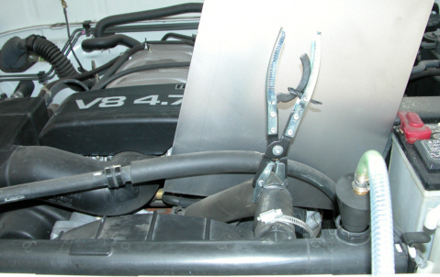

FIGURE M

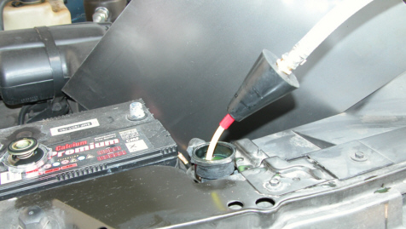

USING THE LONG ¼” TUBE. PUSH TUBE TO BOTTOM OF RADIATOR AND
THEN PUSH CONE DOWN TO SEAL OPENING

FIGURE N

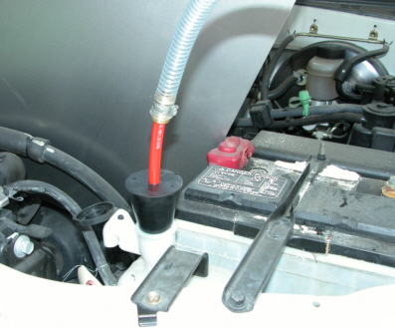

USING THE ORANGE 3/8” TUBE WITH CONE TO SERVICE SEALED SYSTEM.
PUSH THE TUBE DOWN AS FAR AS POSSIBLE AND SEAL OPENING WITH THE CONE.

MAINTENANCE

THE 3- n-1 COOLANT SYSTEM WAS DESIGNED TO GIVE MANY YEARS
OF TROUBLE FREE SERVICE:

THE SERVICES REQUIRED ARE:

- CHECK THE AIR PRESSURE GOING TO THE “PUSH/PULL SWITCH”.

- CHECK THE TENSION ON THE STAINLESS STEEL ROD HOLDING THE TUBE CAPS IN TENSION.

- PERIODICALLY CLEAN THE TUBE.

THE AIR PRESSURE USED TO POWER THE PUSH/PULL SWITCH IS CONTROLLED BY A PRESSURE REGULATOR MOUNTED ON THE BACK SIDE PANEL (FIGURE “O”).
THE PRESSURE IS SET AT THE FACTORY FOR 25 PSI. UNDER NO CIRCUMSTANCES SHOULD THE PRESSURE EVER BE ALLOWED TO EXCEED 30 PSI. CHECK THE GAUGE LOCATED ON THE PRESSURE REGULATOR FREQUENTLY TO INSURE IT READS 25 PSI.

FIGURE O

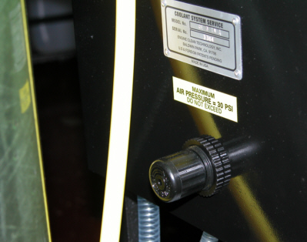

SYSTEM MAINTENANCE-CONTINUED

IN THE EVENT THE QUAD SEAL LOCATED AT THE BOTTOM OF THE TUBE LEAKS
( FIGURE “P”) TIGHTEN THE TUBE TENSION NUT LOCATED UNDER THE 5/8” CAP.
USE A 7/16 SOCKET TO TURN THE NUT 1/8 TURN. RECHECK FOR LEAKS. CONTINUE TO TIGHTEN IN 1/8 TURN INCREMENTS AS NECESSARY TO RESEAL.

TO REMOVE THE TUBE FOR CLEANING REMOVE THE 5/8” CAP, THE TENSION NUT,
2 BELLVILLE WASHERS AND 1 FLAT WASHER. IT MAY BE NECESSARY TO DISCONNECT THE PLASTIC LINE GOING INTO THE TOP CAP. WIGGLE THE CAP OUT OF THE TUBE. CLEAN THE TUBE WITH SOAP AND WATER, DO NOT USE BRAKE CLEANER OR OTHER FLAMMABLE CLEANERS. REMOVE THE BOTTOM QUAD SEAL AND CLEAN IT AND IT’S GROOVE. REINSTALL THE QUAD SEAL AND THE TUBE. LUBE THE TOP O-RING WITH LIQUID SOAP-DO NOT USE GREASE-AND REINSTALL THE TOP CAP. LOCATE THE FLAT WASHER AND BELLVILLE WASHERS. ON THE BELLVILLE WASHERS THE CUP SIDES FACE EACH OTHER AS SHOWN IN FIGURE “P”. INSTALL THE TENSION NUT AND TORQUE TO 35 INCH POUNDS. IF YOU DO NOT HAVE A TORQUE WRENCH SNUG THE NUT DOWN AND CHECK FOR LEAKS. INCREASE THE TENSION 1/8 TURN AT A TIME UNTIL THE LEAK STOPS.

TO CHECK THE TUBE FOR LEAKS INSTALL 2 OR 3” OF WATER IN THE TUBE BY REMOVING THE 22mm CAP ON THE TUBE TOP. USING THE HOSE BIB AND THE PUSH/PULL SWITCH PUMP THE WATER INTO THE TUBE. TURN THE TUBE CONTROL KNOB TO “OLD” AND MAIN CONTROL KNOB TO “PRESSURE” WHILE HOLDING YOUR FINGER OVER THE END OF THE SERVICE LINE. THE PRESSURE GOING INTO THE TUBE IS ONLY ABOUT 12 TO 18 PSI. CHECK FOR LEAKS AND PROCEED ACCORDINGLY.

SERVICE TIP: LUBE THE ORANGE TUBE WITH ETHYLENE GLYCOL SO THE RUBBER CONE WILL SLIDE EASILY.

3-N-1 COOLANT ACCESSORIES ECS KIT PN 39999

- Orange Hose With Black Cone (PN 30150)

- Pliers (PN 30159)

- Hose Bib with Chuck End
(PN 30161)

- Black Cone with Short Orange Hose (PN 30158)

- Step Cone (PN 30205)

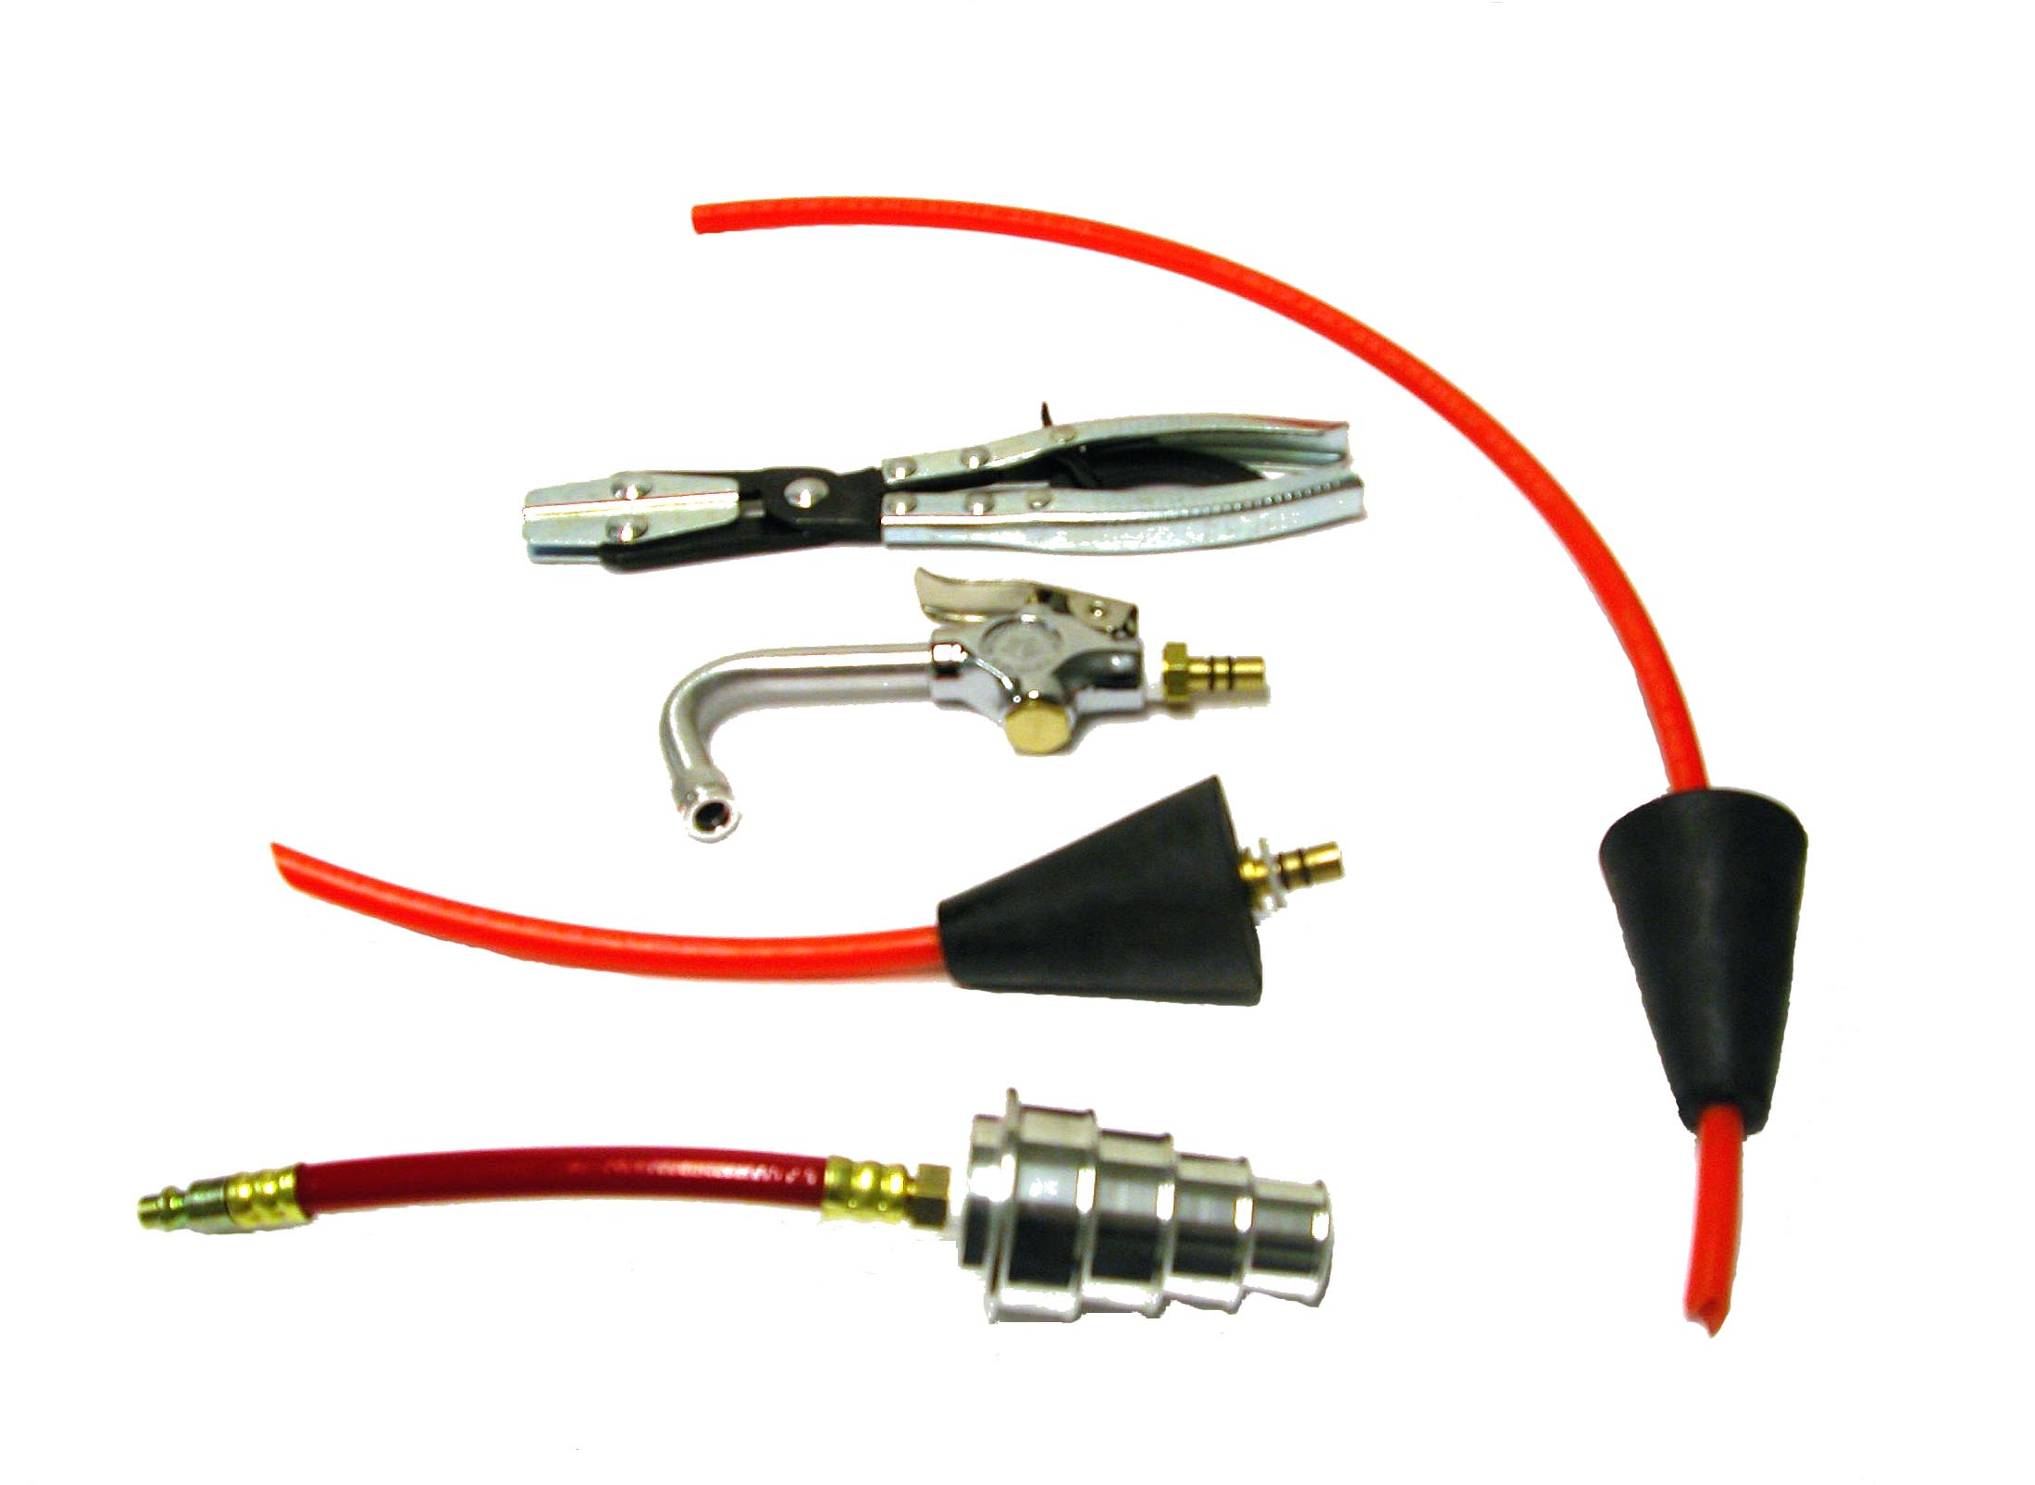

LIMITED WARRANTY

This product is warranted by ENGINE CLEAN SOLUTIONS, INC. to be free of defects in workmanship and materials for a period of one year from date of purchase by original purchaser. If the product fails within this period, it will be repaired or replaced at seller’s option; provided (1) the product is submitted with proof of purchase date and (2) transportation charges are prepaid to the nearest Service Center. Liability under this warranty is expressly limited to repairing or replacing the product or parts thereof. This warranty does not apply to product or parts broken by accident, negligence, overload, abuse, or if they have been tampered with in any way. This warranty does not apply to service hoses and adapters which may need replacing do to normal wear. If this warranty does not apply, then the purchaser shall pay all costs for labor, material and transportation. Note: The use of this apparatus for any purpose other than the services described will render this warranty null and void. No other warranties are expressed or implied.

OWNER REGISTRATION CARD

IN ORDER FOR THIS MACHINE TO BE COVERED BY THE WARRANTY, THE OWNER REGISTRATION CARD MUST BE FILLED OUT BY THE END-USER AND RETURNED TO THE FACTORY WITHIN 30 DAYS FROM THE DATE OF DELIVERY.

DATE OF PURCHASE: ____________________________

MACHINE SERIAL NUMBER: ______________________

MACHINE MODEL NUMBER: _____________________

NAME OF PURCHASER: __________________________

COMPANY NAME: _______________________________

STREET ADDRESS: _______________________________

CITY, STATE, COUNTRY: _______________________________________

TELEPHONE NUMBER: ______________________________________

FAX NUMBER: ______________________________

RETURN THIS REGISTRATION CARD TO:

ENGINE CLEAN SOLUTIONS, Inc.
5112 Heintz Street
Baldwin Park, CA 91706
FAX: (626) 814-8738

