**EGR SERVICE FORD DIESEL VEHICLES**

Connect the diesel vehicle’s OBD receptacle to a diagnostic computer for reading and recording the existing codes. Document the existing codes and clear all readings prior to starting the process.

Use the ECS EGR System Cleaning Kit, to safely remove the deposits from the EGR Control Valve, and EGR Cooler, and EGR Intake system.

Start the vehicle and allow it to reach operating temperature. Turn the vehicle “off” when the operating temperature is finally reached.

Locate the EGR control Valve and unplug the electrical connector. Loosen the two (2) Flange Bolts and remove the EGR Control Valve from the engine with the Ford removal tool. In some extreme cases, the EGR Control Valve may be stuck in place due to excessive carbon build-up around the Silicon O-rings. Slightly tap and turn the EGR Control Valve to loosen it up. Be careful not to damage the O-rings. Be careful not to damage the O-rings during the removal process.

Carefully remove the (2) two Silicone O-rings, inspect them for cuts, and replace if damaged or hardened. Note: Never lay-down or turn the EGR Control Valve upside down during the cleaning process. Cleaner migrating into the electronics may cause damage and possibly render the EGR Control Valve useless.

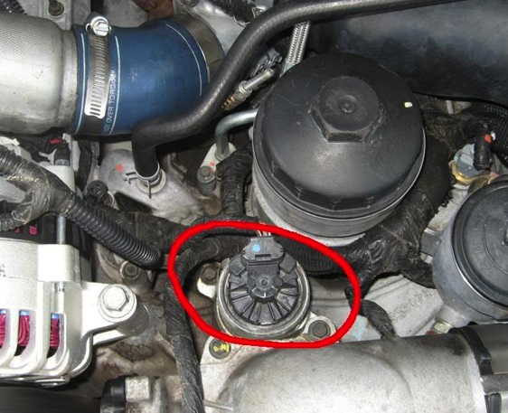

**I. CLEAN EGR VALVE**

To pre-clean the EGR Valve, use a medium bristled brush to remove as much carbon as possible. Using the extension straw, spray a small amount of D-501 Diesel EGR System Cleaner onto the area with carbon deposits. Allow the solution to penetrate for 2-5 minutes to breakdown and mobilize these particles for easy removal. Rinse, wipe clean, and reapply product as necessary. Allow the EGR Control Valve to completely dry prior to installing the two Silicon o-rings. The o-rings should be coated with a small amount of silicone spray or grease to protect then during reassembly. Put the EGR control valve aside for final assembly.

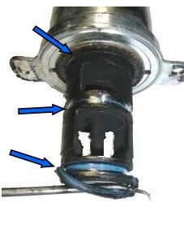

**II. CLEAN COOLANT TUBES**

Using the Extension Straw, apply D-501 into the outlet passage of the EGR cooler in short three-five second bursts. Allow the cleaning solution to penetrate for 2-5 minutes between bursts. This will allow the formulation to loosen, dissolve, and clean the deposits form the affected areas. Reapply as necessary.

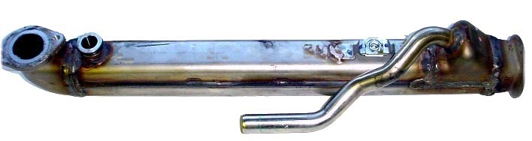

**III. CLEAN EGR INDUCTION SYSTEM**

Spray and pre-clean the EGR Port Hole and Manifold areas with ECS Diesel EGR System cleaner prior to installing ’s Diesel EGR Tool Adapter. Begin by installing the EGR Valve adaptor fitting into the manifold port hole. The tool is press-fit into place and held securely by vacuum and two o-rings. Be careful not to damage the adaptor o-rings during the installation process.

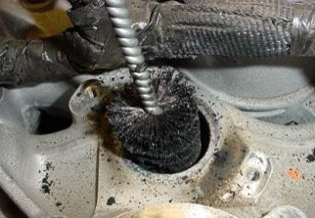

Make sure that the valve on top of the DIESEL FUEL TOOL is in the closed position see figure 1. Install the supply tool on the 18 oz container of D-501 diesel cleaner. Connect the supply hose to the EGR valve adapter and supply tool as shown in figure two.

Separate the air tube duct that runs from the intake plenum to the turbo outlet and install the ECS air intake adaptor plug on the engine side to create a vacuum.

After inserting the air intake adapter into the duct, turn the silver cap-clockwise to expand the o-ring and fasten it in place. This will create the vacuum that is necessary to carry cleaner through the EGR runners and cavities.

Start the vehicle and allow the engine to reach full operating temperature. Use a throttle depressor-if necessary, to maintain 1000 RPM. Open the supply tool valve to allow the D-501 Diesel Induction system cleaner to flow through the EGR Tool and begin the system cleaning.

The EGR system cleaning is complete when product is no longer flowing from the diesel induction system cleaner to the EGR tool.

Turn-off the engine and remove the EGR valve adapter fitting, air intake adapter, and supply tool from the vehicle.

Reinstall the cleaned or new EGR control valve into the manifold port. Be careful not to damage the two o-rings during assembly and torque the two fastening screws to OEM specifications.

Plug into the EGR control valve electrical connector and reconnect the air tube duct to the turbo.

Restart the vehicle and run for 15 minutes at 1,500 -2,000 rpm to dry out pockets of cleaner that may have accumulated in the system.

The cleaning process is now completed.

